Deliverable 3 Report
1: Table Of Contents
2: Project Background, information copied from Deliverable 1.
3: Class Diagram, and link to a clearer image of it.
4: GitHub Link.
5: Conclusion.

Project Background
The database being created here is for a trinket shop, though a highly unusual one recently under legal investigation after some items were stolen from their stock but it was discovered other items were stolen before being sold to them, illegally imported, or not legal to sell in Canada at all. The disorganization of the store's current system allowed for all these problems to come up, and a database showing in detail what is there, what quantity it is in, who sold it to them, the price it was bought for and price being sold for, when it was acquired, and the status of the item as in whether it must be disposed of or is safe to sell.

The intention of the program is to be usable by anyone and everyone who would open it, even if they have no idea what they’re doing, and this will be (and was) tested throughout the project by someone I am close with who isn’t too good with computers. Questions and points of confusion they brought up as I worked were turned into modifications for the code, between the development of the code I had in Deliverable 2 and what I have now.

Class Diagram:
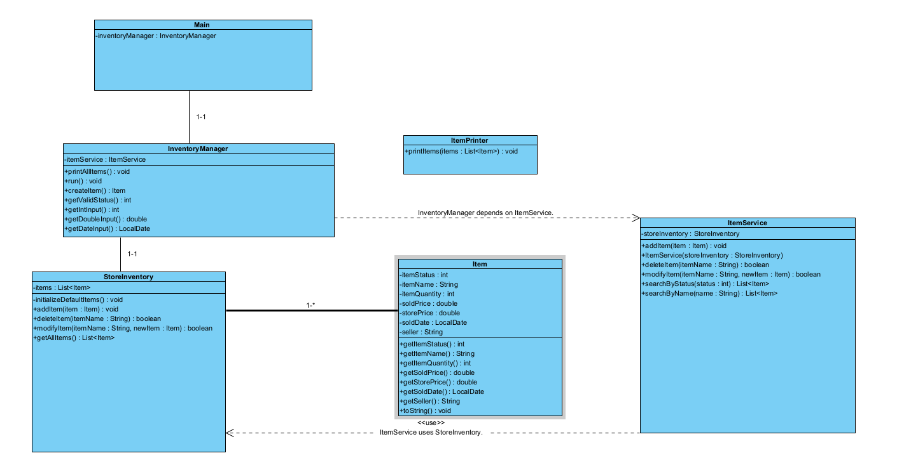
https://files.catbox.moe/1uaub8.png
Two new classes were added for better organization and encapsulation, InventoryManager was greatly expanded and modified too though that isn’t too obvious at first glance. You will discover what I mean upon seeing the code.

https://github.com/BreezerInYourFreezer/TrinketShopProject

This project concluded with something that serves its purpose to the point, with nothing extra added and nothing left out that’d leave a new/not-tech-savvy user confused. Never was it intended to be anything too complex, as that’d kind of defeat the point of what this code is supposed to do.
A scrapped feature was item descriptions, though I believe it could be added again relatively easily if I wanted to bring it back. It was canned due to newline/display errors with typing out the descriptions making the output look strange.
One addition was lines that print to make modifying an item and creating an item easier to understand: for someone that doesn’t know what the return types mean for example, it prints exactly what you should put in to get your intended result. Decimal numbers, integers, and text/names. As well as that, when an invalid input is done it sends the request again rather than having an error or shutting down for better functionality. Another addition from before was limiting the statuses to 1, 2, and 3 and sending an error message when one is attempted to be changed to something else, for simplicity when setting the status of an item and to make sure there are no typos or unintended numbers.
I could have very well combined this with Spring Boot, something for another course I was doing, to make a fully functional database with HTML pages and a user interface rather than just this. Though, I decided against it as that’d be even harder to implement into a class diagram and harder to demonstrate too without a video example.
My overall thoughts on this? I liked the final product and the tester did as well, so I consider that enough of a success to say I pulled this off well enough. Maybe I’ll end up doing more with this for fun, but maybe not.

